**Tiger Spraying Locations**

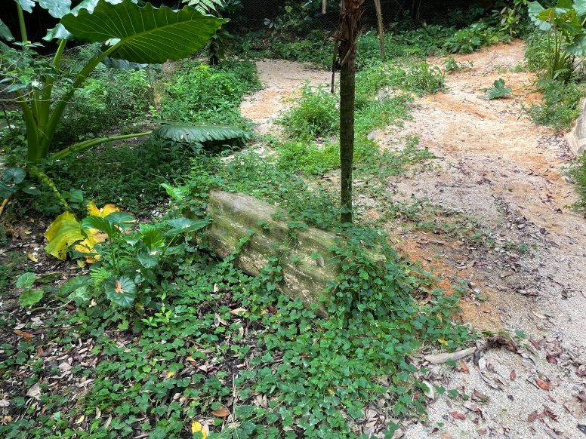**Location A**

Small log located under fan palm, next to yam plant

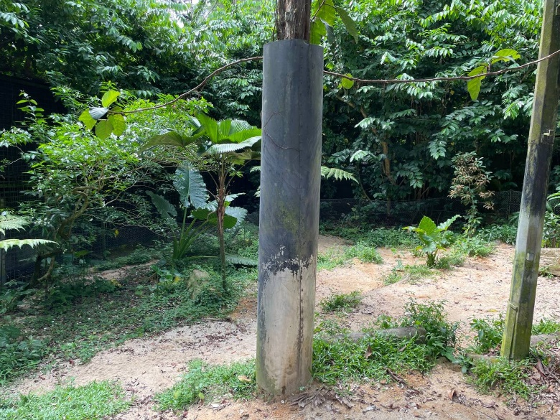**Location B**

Tree with cladding next to lamp post

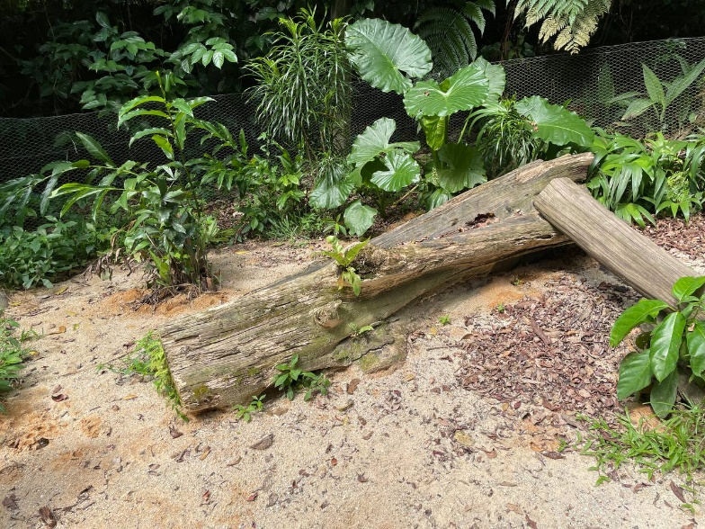**Location C**

Big log at back of exhibit next to yam plant near chicken mesh

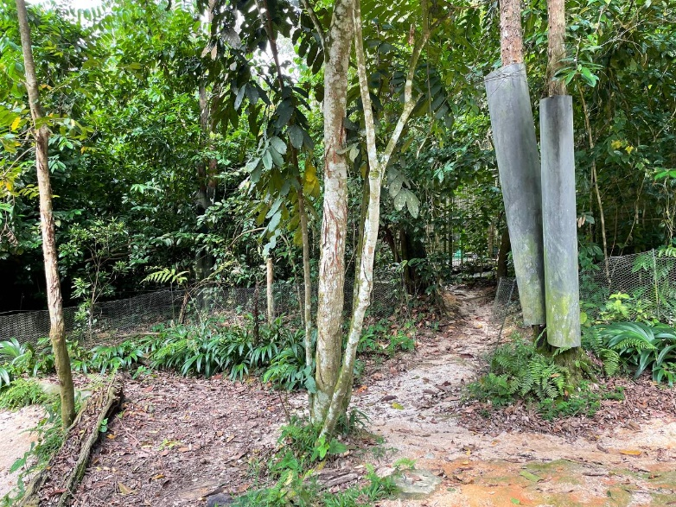**Location D**

Tree with lots of scratches (on the left of tree with zipline)

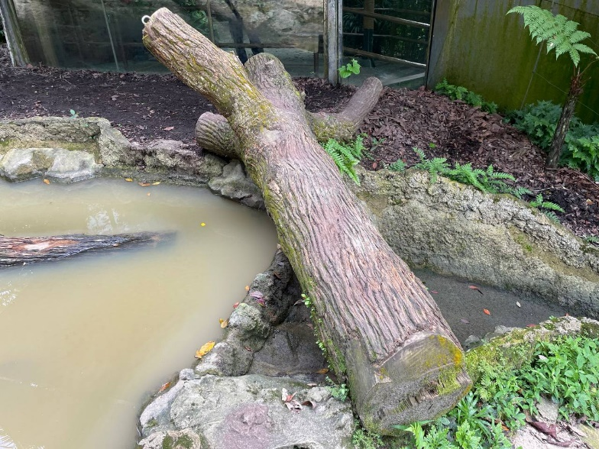**Location E**

Log with 3 arms going across pool (spray on any one area)

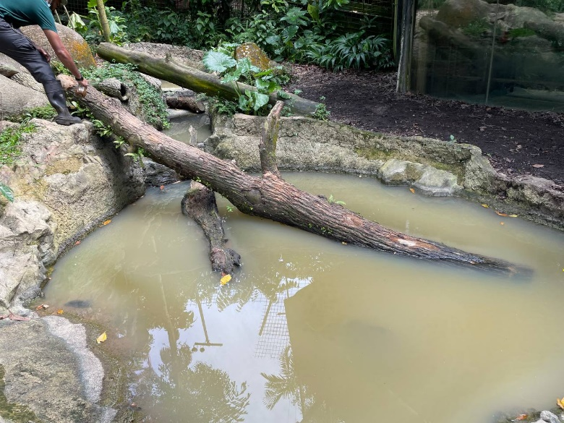**Location F**

Log going into pool (spray on any one area)

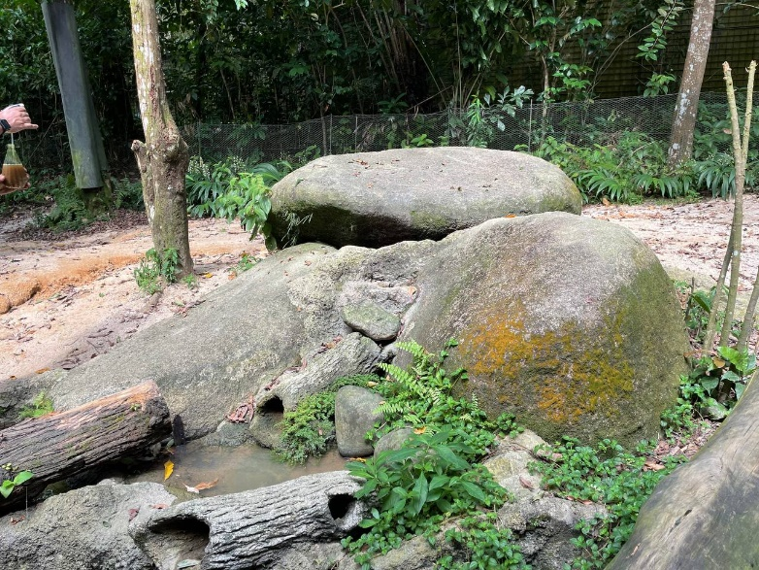**Location G**

Group of boulders (spray on any single location)

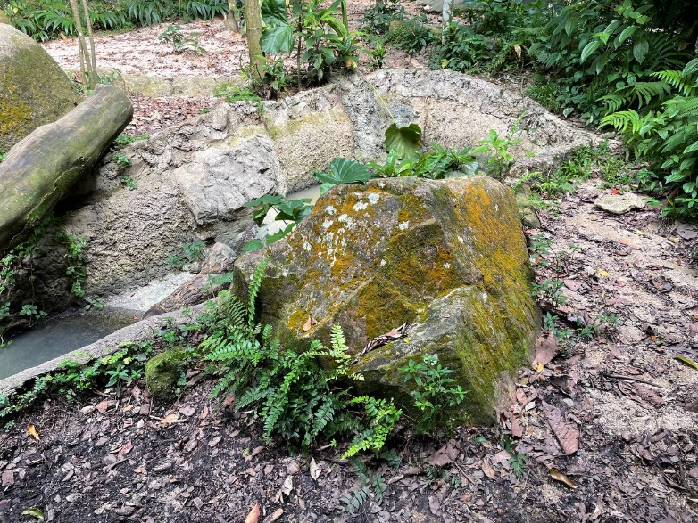**Location H**

Boulder at the top/start of cascade near glass panel

